**Lesson 6: Translating and Evaluating Expressions**

**Do Now:**

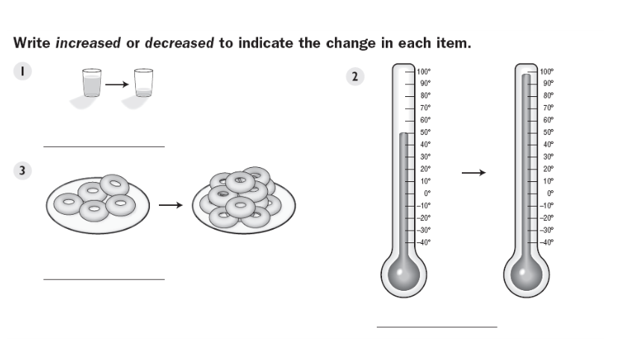

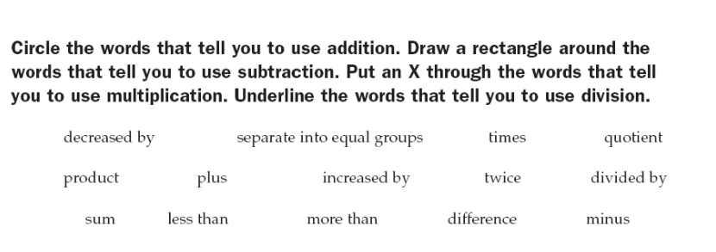

**Key Vocabulary:**

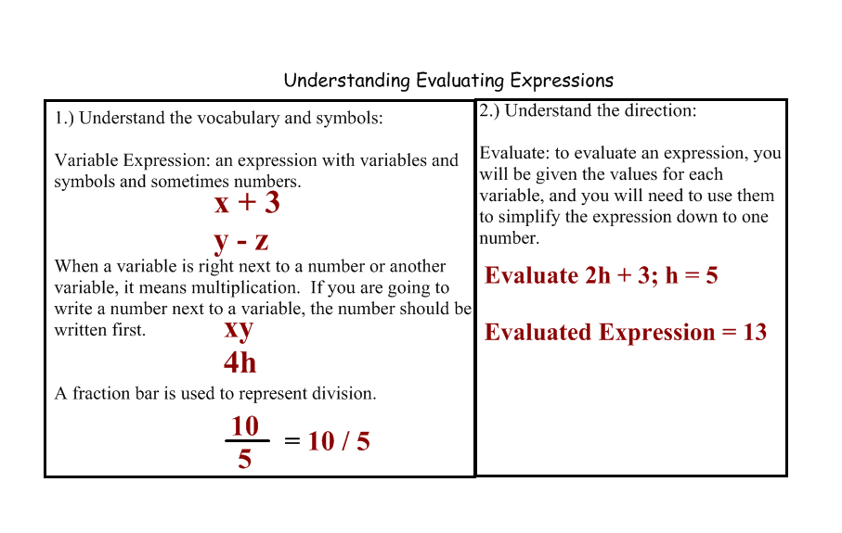

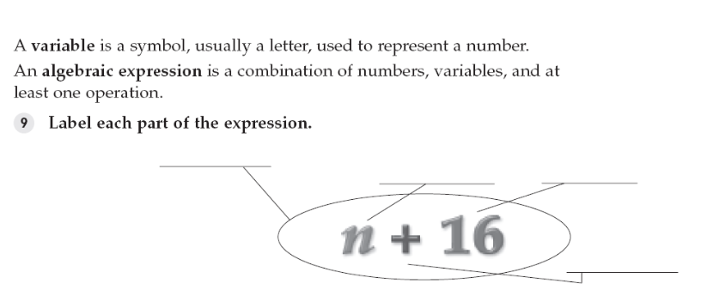

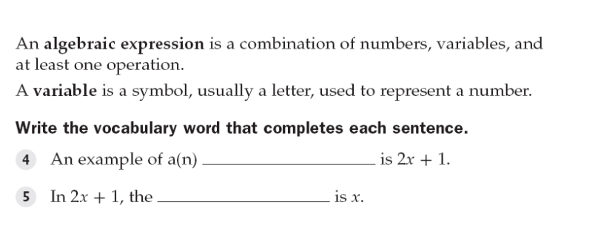

**Guided Notes:**

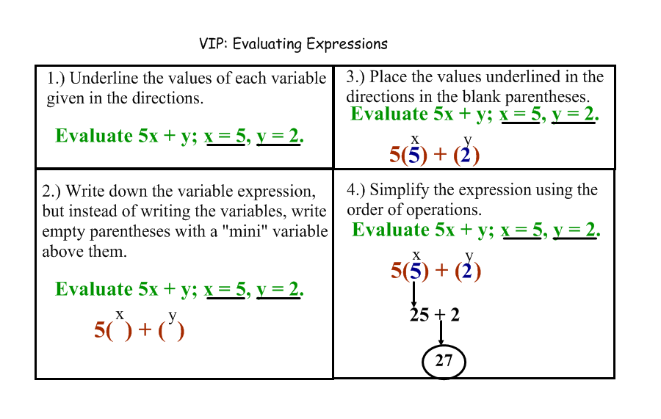

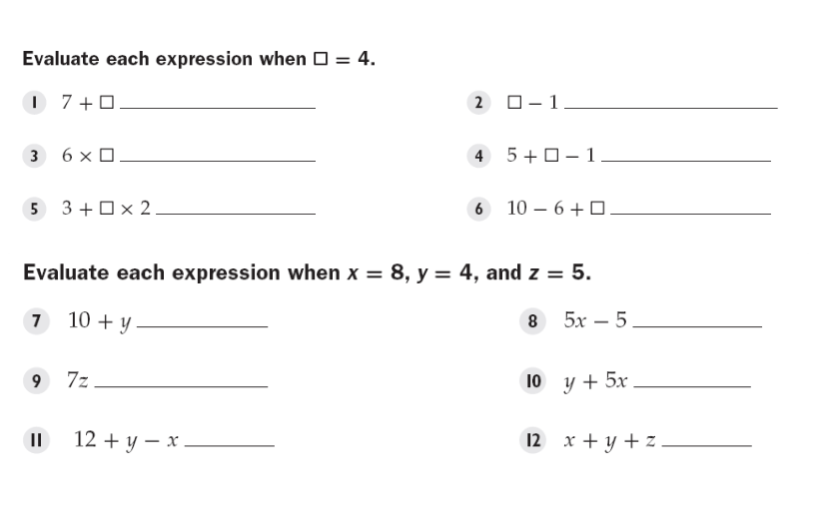

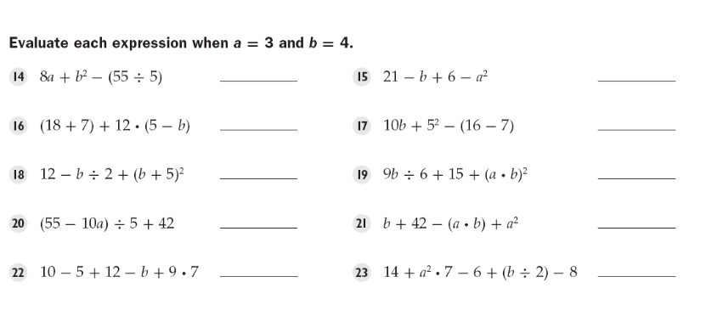

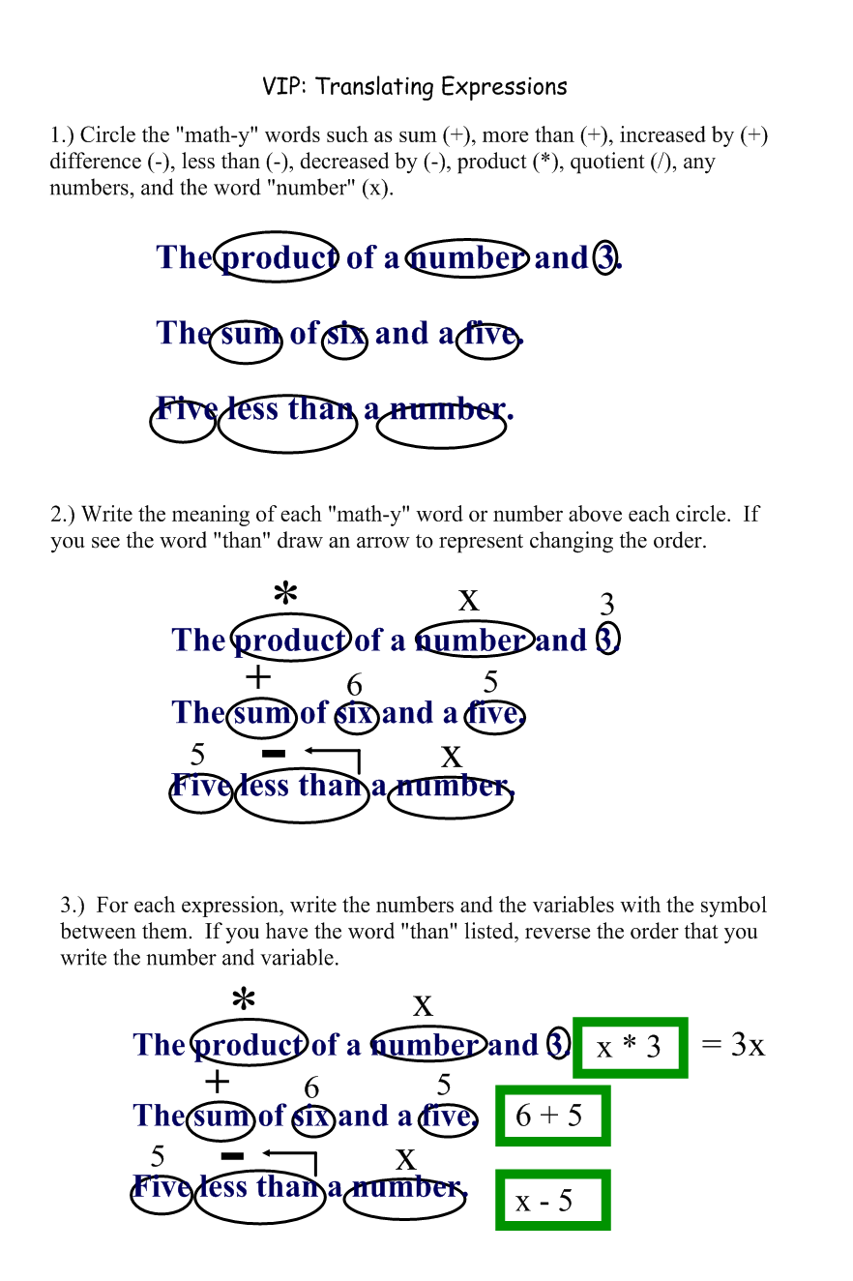

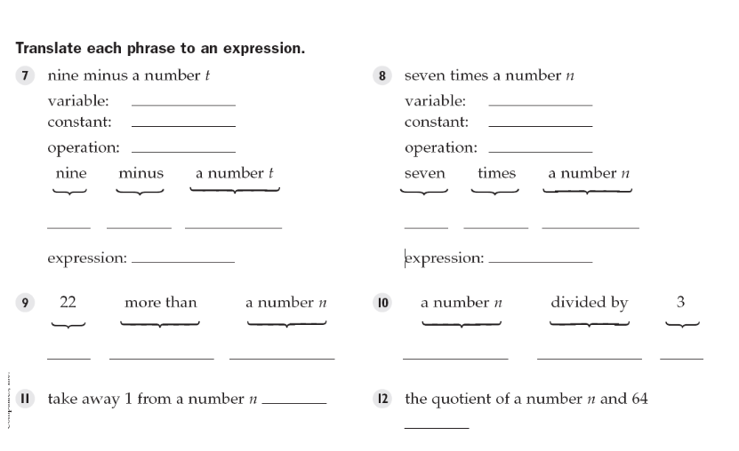

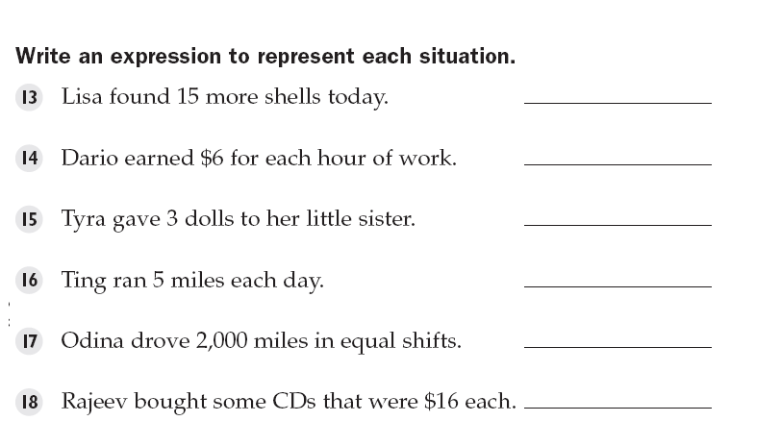

**Structured/Guided Practice:**

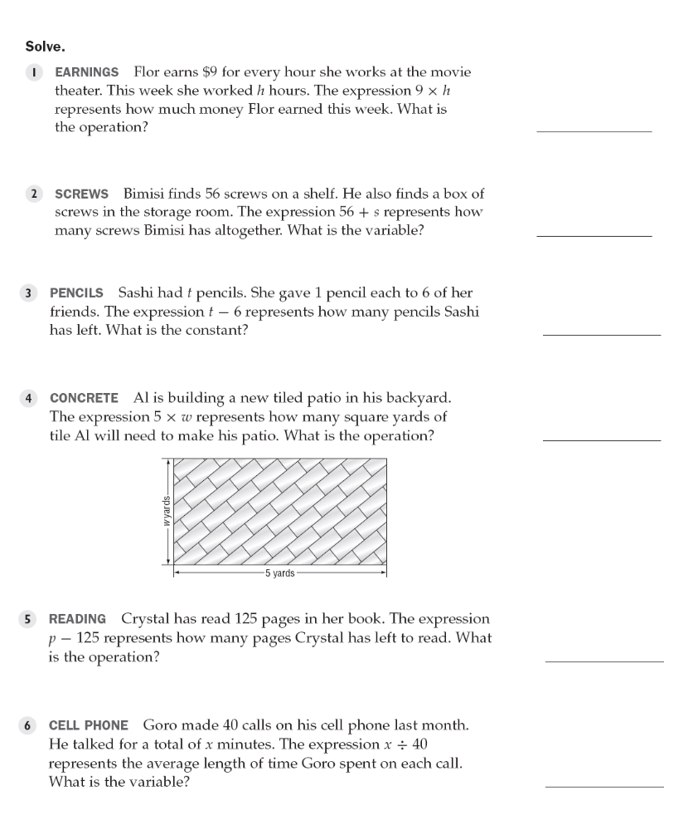

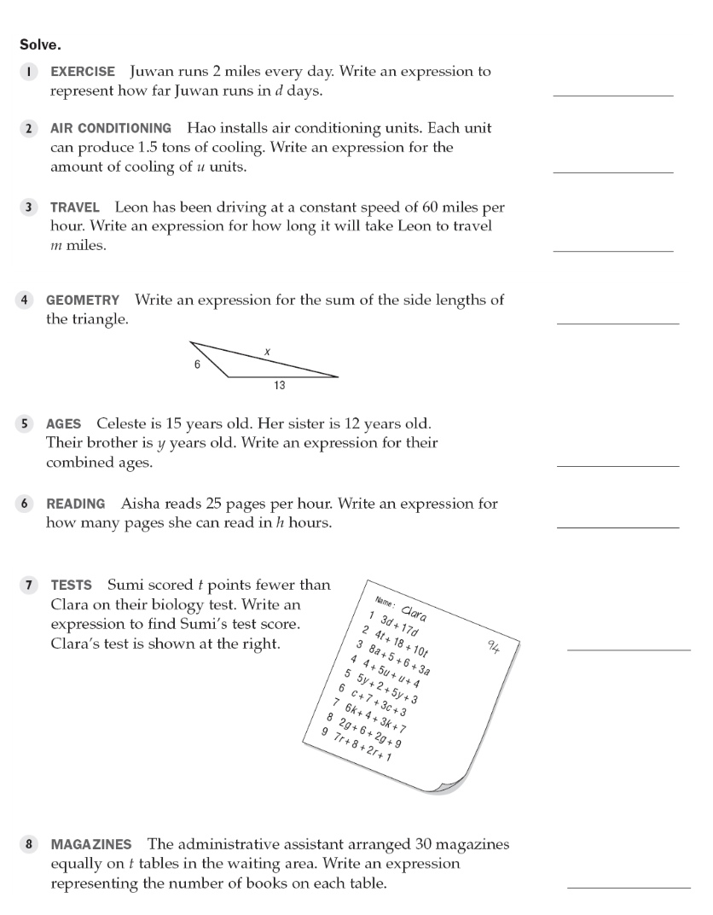

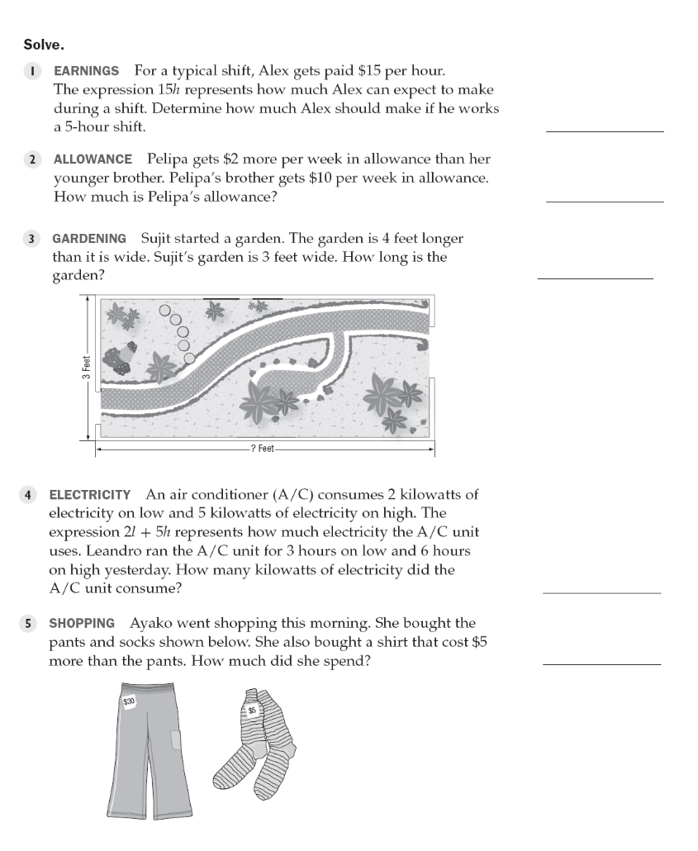

**Independent Practice:**

1. **Evaluate the expression when x = 8, y = 9, and z = 0**
2. **I have twice as many photographs as my brother does. Write an expression that represents the number of photos I have.**
3. **Laura has two more than twice the number of markers I have. Write an expression for the number of markers that Laura has.**
4. **The average cartoon character has one less finger than I do. Write an expression for the number of fingers the cartoon character has (assume you don’t know how many fingers I have).**
5. **I have half the number of cards my brother has. The number of cards my brother has is five times the number of pencils my dad has. The number of pencils my dad has is five more than the number of erasers my mom has. Write an expression for the number of cards I have, in terms of the number of erasers my mom has.**

